**WIRELESS SENSORS NETWORKS**

SUBMITTED BY

PARAG PUJARI

1031310472

COMPUTER SCIENCE

AND ENGINEERING-H

SUBMITTED TO

**MS.B.MONIKA NAIR**

ASST. PROFESSOR

**DEPARTMENT OF ENGLISH AND FOREIGN LANGUAGES**



**2015-2016**

**SRM UNIVERSITY**

KATTANKULATHUR

**BONAFIDE CERTIFICATE**

This is to certify that this project report entitled **WIRELESS** **SENSORS NETWORKS** submitted to the **Department of English and Foreign Languages, SRM University**, is a bonafide record of work done by Mr ,Parag Pujari under my supervision.

Signature

**B.Monika Nair**

**Assistant Professor**

**Department of English and Foreign Languages**

**SRM University**

**Acknowledgement**

First and foremost, I would like to thank my Professor, **Ms.B.MONIKA NAIR MAM** for

the valuable guidance and advice. She inspired me greatly to work in this project. Her willingness to motivate me contributed tremendously to my project. We also would like to thank her for showing us some example that related to the topic of my project. Finally ,an honourable mention goes to our **families and friends** for their understandings and supports on us in completing this project. Without helps of the particular that mentioned above ,I would face many difficulties while doing thus.

**TABLE OF CONTENTS:**

|  |  |  |
| --- | --- | --- |
| **Chapter** | **Title** | **Page No** |
| 1. | **Introduction** | **1** |
| 2. | **Parts of wireless sensors networks** | 2 |
| 3. | **Objectives Of wireless sensors networks** | 3 |
| 4. | **Advantages Of wireless sensors networks** | 4 |
| 5. | **Disadvantages Of wireless sensors networks** | 12 |
| 6. | **Characteristics Of wireless sensors networks** | 13 |
| 7. | **Types Of wireless sensors networks** | 31 |
| 8. | **Importance Of wireless sensors networks** | 33 |
| 9. | **Applications Of wireless sensors networks** | 34 |
| 10. | **Future Scope Of wireless sensors networks** | 35 |
| 11. | **References** | 36 |

**INTRODUCTION**

**1. INTRODUCTION**

**WIRELESS SENSORS NETWORKS**

* It is a specialized transducers communications infrastrutures for recording and monitoring and monitoring conditions at diverse conditions. It helps in providing data to the sensor node.
* It even provides a large amount of mass communication.

**PARTS OF WIRELESS SENSORS NETWORKS**

**2.** **PARTS OF WIRELESS SENSORS NETWORKS**

* Radio transceiver- It provides connection to external antenna. It even provides source

to start up the working of the radio channels.

* Microcontroller- It interfaces sensors with energy source.
* Battery- It provides energy to nodes.
* Sensor node- The main portion of the node which helps in transferring energy to the gateway node.
* Gateway node-It provides the energy to the receiver.

**OBJECTIVES OF WIRELESS SENSORS NETWORKS**

**3.OBJECTIVES OF WIRELESS SENSORS NETWORKS**

* To regulate the environmental temperature.
* To avoid a lot of wiring.
* To accommodate any number of devices at any time.
* To access through a centralized monitor.
* To even helps in transmission of messages of long distances.
* To be reliable to use.
* To help in controlling all types of signals and messages.
* To provide the energy to the receiver.
* To provide scalability to large scale of deployment.
* To provide ability to withstand harsh environmental conditions.
* To provide ability to cope with node failures.
* To help in interconnecting one node to other.
* Tohelp in providing data to the gateway node.

**ADVANTAGES OF WIRELESS SENSORS NETWORKS**

**4.ADVANTAGES OF WIRELESS SENSORS NETWORKS**

1. It avoids a lot of wiring.

2. It helps in regulating environmental temperature.

3. It helps in the connection of various of nodes so as to regulate the working of sensors.

4.It can accommodate any number of devices at any time.

5.It can be accessed through a centralized monitor.

6.It even helps in transmission of messages of long distances.

7.It is even cheap and it is reliable to use.

8.It even helps in controlling all types of signals and messages.

**DISADVANTAGES OF WIRELESS SENSORS NETWORKS**

**5.DISVANTAGES OF WIRELESS SENSORS NETWORKS**

1.It has low speed of communications as compared to other networks.

2.Some of the sensors networks are very costly and is difficult to understand.

3.It even gets distracted by various elements like blue tooth,wifi etc.

4.It is even less secure.

5.It is complex to configure than wired networks

6.It does not make sensing quantities in buildings easier.

7.It does not reduce for installation of sensors.

8.It is very much complex to use.

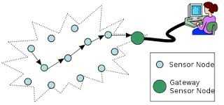

**Diagrammatic Representation of data flow of Wireless Sensors Networks**

CHARACTERISTICS OF WIRELESS SENSOR NETWORKS

**6.CHARACTERISTICS OF WIRELESS SENSORS NETWORKS**

* It is a basic unit of mobile communication.
* It helps in transferring a large amount of data from one node to other.
* It helps in communication information through air without help of any instrument.
* It is a simple means of communication of networks.
* It is easy to user.
* It provides scalability to large scale of deployment.
* It provides ability to withstand harsh environmental conditions.
* It provides ability to cope with node failures.
* It helps in interconnecting one node to other.
* It helps in providing data to the gateway node.
* It helps in providing data to the sensor node.
* It even provides a large amount of mass communication.

**TYPES OF WIRELESS SENSORS NETWORKS**

**7.TYPES OF WIRELESS SENSORS NETWORKS**

* **Terrestrial WSN**- It is capable of handling of several base stations and even consist of several nodes deployed in structured or in unstructured manner. It helps in providing data to the gateway node. It even provides a large amount of mass communication. .It even gets distracted by various elements like blue tooth, wifi etc.It is even less secure.It is complex to configure than wired networks.

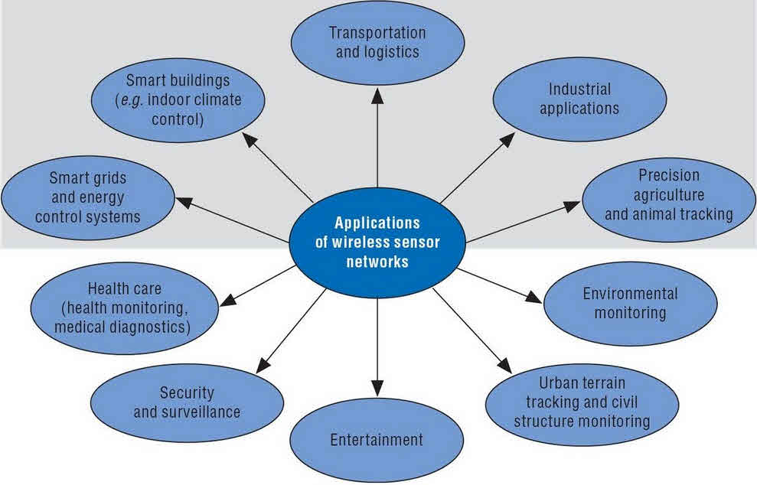

**DIAGRAMMATIC REPRESENTATION OF MOBILE WSN**

* **Underground WSN-** It is more expensive than terrestrial WSN in terms of deployment. It even consists of several nodes hidden underground in order to measure underground environment. It is a basic unit of mobile communication. It helps in transferring a large amount of data from one node to other. It helps in communication information through air without help of any instrument. It has low speed of communications as compared to other networks .Some of the sensors networks are very costly and is difficult to understand .It even gets distracted by various elements like blue tooth, wifi etc.It is even less secure. It is complex to configure than wired networksIt does not make sensing quantities in buildings easier. - It is capable of handling of several base stations and even consist of several nodes deployed in structured or in unstructured manner. It helps in providing data to the gateway node.

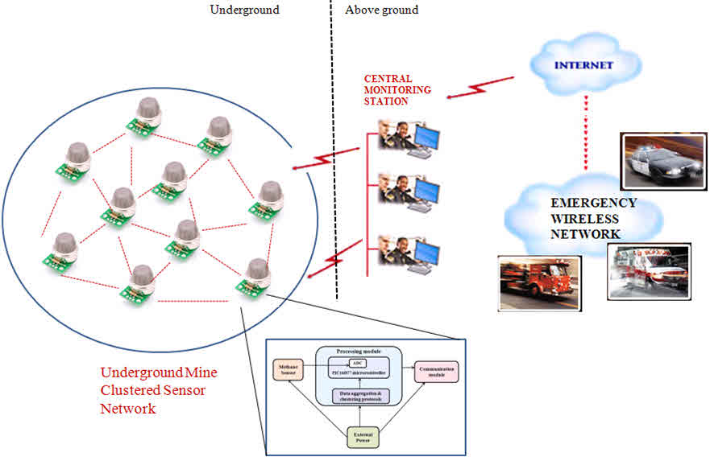

**DIAGRAMMATIC REPRESENTATION OF UNDERGROUND WSN**

* **Multimedia WSN-**More than 70% of the earth is occupied with water. These networks consist of a number of sensor nodes and vehicles deployed under water. Autonomous underwater vehicles are used for gathering data from these sensor nodes. A challenge of underwater communication is a long propagation delay, and bandwidth and sensor failures. It helps in providing data to the sensor node.It even provides a large amount of mass communication. It helps in providing data to the sensor node. . It helps in transferring a large amount of data from one node to other. It helps in communication information through air without help of any instrument. It has low speed of communications as compared to other networks .Some of the sensors networks are very costly and is difficult to understand .It even gets distracted by various elements like blue tooth, wifi etc.It is even less secure. It is complex to configure than wired networks. It does not make sensing quantities in buildings easier. - It is capable of handling of several base stations and even consist of several nodes deployed in structured or in unstructured manner. It is even less secure.It is complex to configure than wired networksIt does not make sensing quantities in buildings easier.

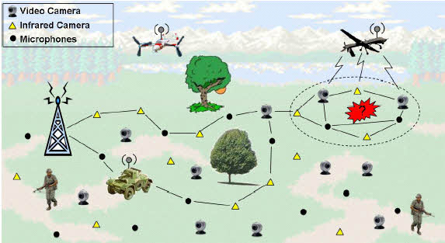**DIAGRAMMATIC REPRESENTATION OF MULTIMEDIA WSN**

**IMPORTANCE OF WIRELESS SENSORS NETWORKS**

**8.IMPORTANCE OF WIRELESS SENSORS NETWORKS**

* It helps in transferring a large amount of data from one node to other.
* It helps in communication information through air without help of any instrument.
* It is a simple means of communication of networks.
* It avoids a lot of wiring.
* It even consists of several nodes hidden underground in order to measure underground environment.
* It helps in regulating environmental temperature.
* It helps in the connection of various of nodes so as to regulate the working of sensors.
* It can accommodate any number of devices at any time.
* It can be accessed through a centralized monitor.
* It even helps in transmission of messages of long distances.
* It is even cheap and it is reliable to use.
* It even helps in controlling all types of signals and messages.
* It helps in communication information through air without help of any instrument.
* It is a simple means of communication of networks.
* It is a basic unit of mobile communication.
* It plays a major role in reducing the cost of the cable.
* It even helps in miniaturizing and hardening Wireless measurement protocols.
* It helps in measuring temperatures and prevent our environment from harsh conditions.
* It is a hot spot area in CSE and it is a major source in wireless and mobile communications.

**APPLICATIONS OF WIRELESS SENSORS NETWORKS**

**9.APPLICATIONS BASED ON WIRELESS SENSORS NETWORKS**

* Area Monitoring- It is deployed over a region wherea phenomenon is to be monitored.
* Industrial Monitoring- It is deployed over an industrial area where some industrial techniques has to be monitored.
* Environmental Protection- It protects our environment from various landslides, landslides and flooding.
* Balancing of Sensors-It helps in the connection of various of nodes so as to regulate the working of sensors.It can accommodate any number of devices at any time.
* Transferring of data- It helps in transferring a large amount of data from one node to other.It helps in communication information through air without help of any instrument.

**FUTURE SCOPE OF WIRELESS SENSORS NETWORKS**

**10.FUTURE SCOPE ON WIRELESS SENSORS NETWORKS**

* It is a basic unit of mobile communication.
* It helps in transferring a large amount of data from one node to other.
* It helps in communication information through air without help of any instrument.
* It is a simple means of communication of networks.
* It is easy to user.
* It provides scalability to large scale of deployment.
* It provides ability to withstand harsh environmental conditions.
* It provides ability to cope with node failures.
* It avoids a lot of wiring.
* It even consists of several nodes hidden underground in order to measure underground environment.
* It helps in regulating environmental temperature.
* It helps in the connection of various of nodes so as to regulate the working of sensors.
* It can accommodate any number of devices at any time.
* It can be accessed through a centralized monitor.
* It even helps in transmission of messages of long distances.
* It is even cheap and it is reliable to use.
* It even helps in controlling all types of signals and messages.
* It avoids a lot of wiring.
* It helps in regulating environmental temperature.
* It helps in the connection of various of nodes so as to regulate the working of sensors.
* It can accommodate any number of devices at any time.
* It can be accessed through a centralized monitor.

**REFERENCES**

**11.REFERENCES**

* "ERIS Project Starts". ESOAnnouncement. Retrieved 14 June 2013.
* "3D Scanning Advancements in Medical Science". Konica Minolta. Retrieved 24 October 2011.
* Jon Radoff, Anatomy of an MMORPG, August 22, 2008
* "3D Printing Toys". Business Insider. Retrieved 25 January 2015.